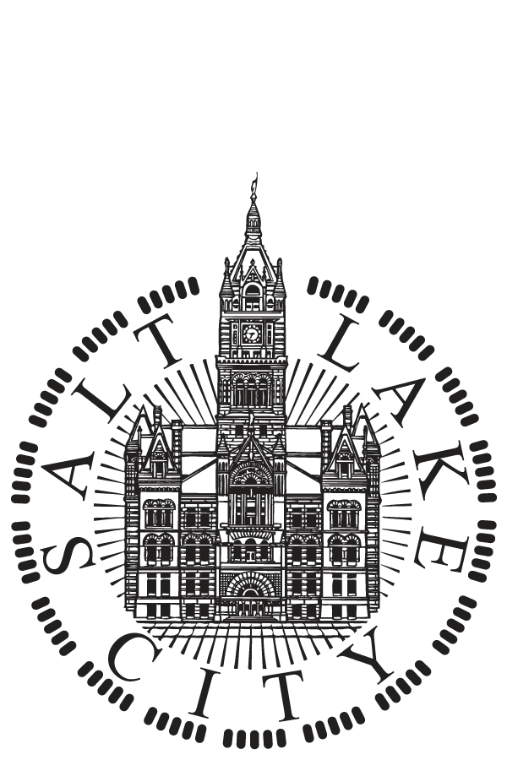 | SALT LAKE CITY  NOTICE OF PUBLIC HEARING  March 15, 2016 at 7:00 p.m.

NOTICE IS HEREBY GIVENT THAT ON Tuesday, March 15, 2016 at 7:00 p.m. a public hearing will be held in Room 315, Council Chambers, City County Building, 451 South State, Salt Lake City, Utah, before the Salt Lake City Council to accept public comment on proposed projects and activities to be undertaken with 2016-17 federal funds under the following U.S. Department of Housing and Urban Development (HUD) programs:

- Community Development Block Grant (CDBG)
CDBG funds may be used for the development of viable urban communities by providing decent housing and suitable living environments for persons of low and moderate-income.
- Emergency Solutions Grant (ESG)
ESG funds may be used to assist individuals and families regain housing stability after experiencing a housing or homelessness crisis.
- HOME Investment Partnership Program (HOME)
HOME funds may be used to create affordable housing opportunities for low-income households.
- Housing Opportunities for Persons with AIDS (HOPWA)
HOPWA funds may be used to provide housing assistance and related supportive services to persons living with HIV/AIDS and their families.

Prior to making funding decisions on the 2016-17 program year, the Salt Lake City Council will consider and review all comments received at the public hearing, as well as funding recommendations provided by Mayor Biskupski and citizen advisory boards. Information about funding recommendations can be found on Salt Lake City’s HAND website at www.slcgov.com/HAND.

If you are unable to attend the hearing and want your voice to be heard, written comments may be submitted to Jennifer.Schumann@slcgov.com. Comments will also be accepted by the Salt Lake City Council office at 451 South State Street, Room 304, PO Box 145476, Salt Lake City, Utah 84111, or emailed to council.comments@slcgov.com. Additionally, messages may be left on the Council comment telephone number; 801-535-7654. Comments must be submitted by April 1, 2016.

EQUAL OPPORTUNITY PROGRAM
Reasonable accommodations for individuals with disabilities or those in need of language interpretation services can be provided if four working days’ notice is given by calling 801-535-7777. Hearing impaired who wish to attend this meeting should contact our TDD service number, 801-535-6021,four days in advance so an interpreter can be provided. Physical access entrance and parking are located on the east side of the building.

